B201 COMPUTER SCIENCE LAB

**Table of Contents**

Introduction 3

Portfolio Website Design 3

Structure of the Portfolio Website 3

GitHub Repository 4

Design and Implementation 5

Design Decisions 5

Technologies Used 6

Functionality 6

Tools/Technologies Used 7

Web Development Tools 7

Hosting Tools 8

Strengths and Weaknesses of the Portfolio 8

Strengths 8

Weaknesses 8

Future Improvements 8

Critical Evaluation 9

Portfolio Structure Evaluation 9

Content Evaluation 9

Reflection on Design Choices 9

Conclusion 9

References 10

# Introduction

This portfolio aims to present technical skills, experiences, and accomplishments in computer science. When applying as a working student, a detailed and structured portfolio showing skills, work experience, and academic qualifications is essential. The portfolio should give prospective employers a balanced picture of the skills and interests in the computer science field, as well as demonstrate a desire to self-develop and improve.

This project will cover the design and development of a personal portfolio site that will be deployed on GitHub Pages. The site will also be an online reflection of the professional and academic experience with pages like About Me, an extensively detailed CV made with LaTeX, a portfolio of technical projects of interest, and a summary of work experience. This portfolio will be developed with the help of technologies and tools, like HTML, CSS, GitHub Pages, and LaTeX, which are used to format professional documents.

The making of a personal portfolio is a required career development process for any computer science student. It enables the person to present their technical abilities, projects, as well as achievements in a well-organized and attractive way. This portfolio can be used as a means of seeking employment, but also as a platform for constant self-development and communication with colleagues. A good portfolio speaks volumes about technical competence and enthusiasm for the subject.

# Portfolio Website Design

## Structure of the Portfolio Website

The portfolio site is created with the aim of presenting professionally and conveniently the skills, experiences, and accomplishments in the sphere of computer science. The site is divided into four key pages: "Home", "About", "Projects", and "Contact", which help to demonstrate the technical skills of the person and their life experience.

1."Home": The home page welcomes the person and gives a short summary of the person. It has a greeting message and a profile picture, which is circular to make the site personal. The design and color used in the site make an attractive introduction that catches the eye of the visitor. A basic navigation bar is also present in the header, in case of the need to access the rest of the site.

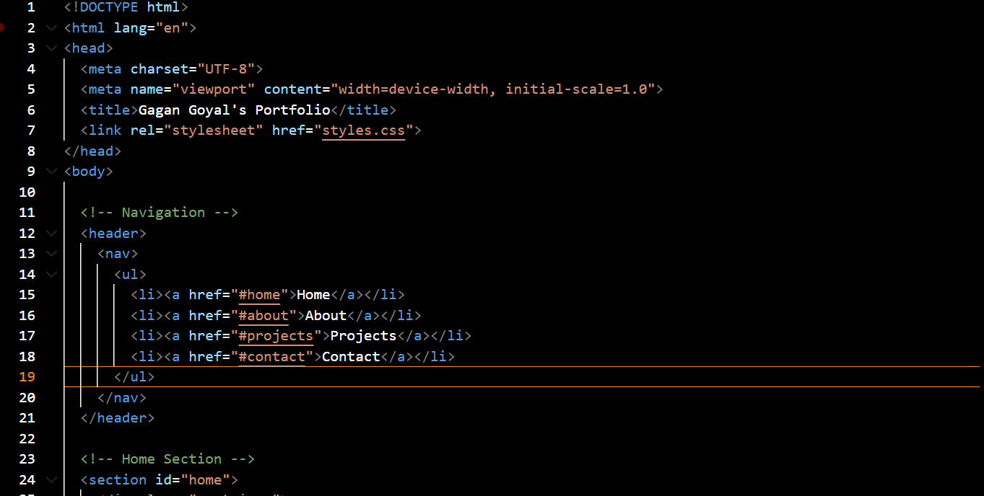

**Figure 1: HTML Code**

**(**Source: VS Code**)**

2. "About": This segment is going to describe in detail the academic background of the person as well as their skills and interests. It mentions the ongoing education that the person is acquiring, the associated subjects, and technical skills. This section is critical so that the prospective employers or partners know the academic background and the career path of the person.

3. "Projects": The Projects section presents one of the most important parts of the portfolio, as it demonstrates the practical use of the skills. It showcases the important projects that one has been engaged in, like web development, machine learning, or data science. All projects have a brief description, some major technologies, and a link to more info or GitHub repositories. Hover effects on the project cards are used to increase the interactivity of the section.

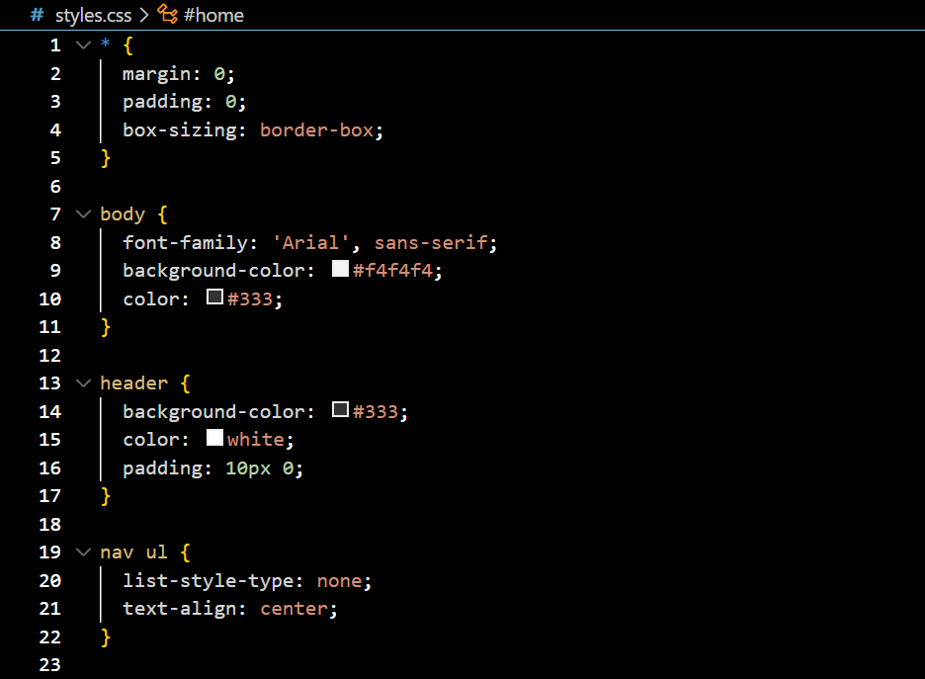

**Figure 2: CSS Code**

**(**Source: VS Code**)**

4. "Contact": The contact form will contain simple contact details, including email and phone number. This section also makes it easy to be contacted by potential employers, partners, or clients.

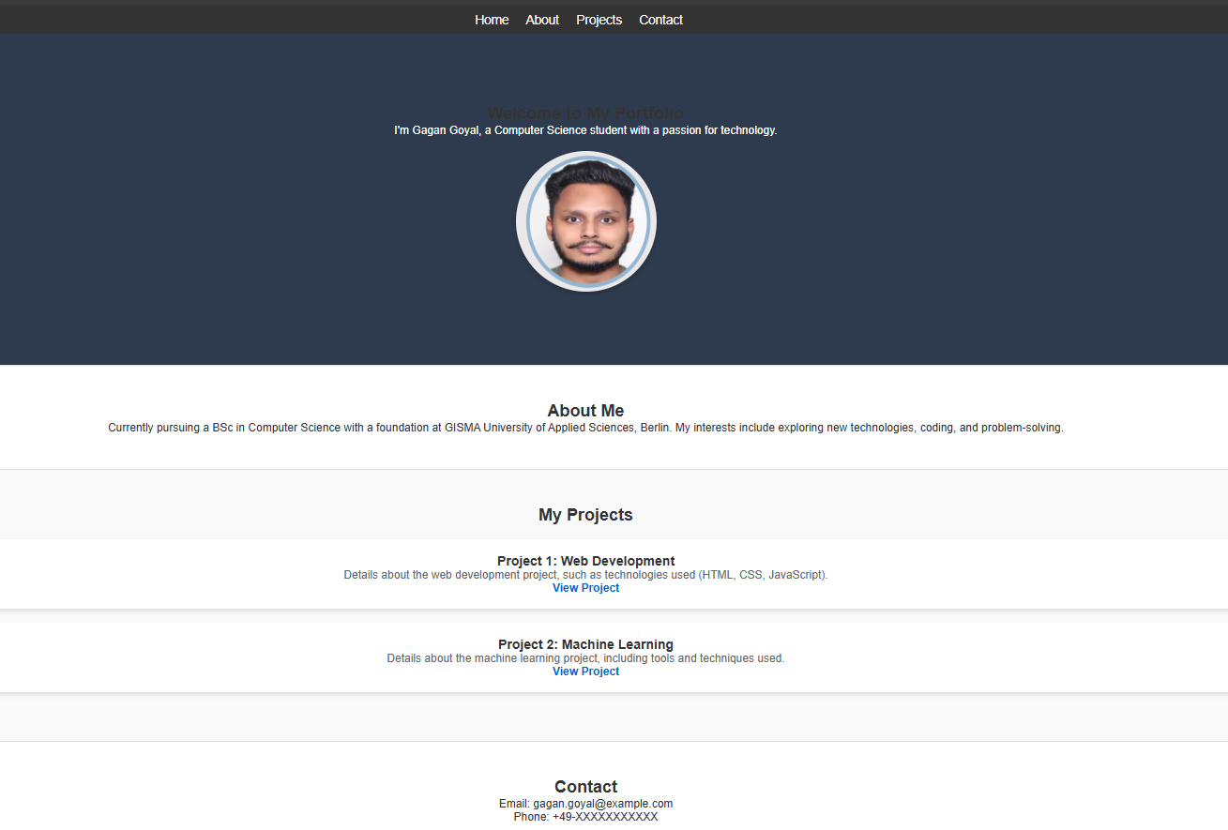

**Figure 3: Portfolio**

**(**Source: VS Code**)**

This layout makes the portfolio well-organized, user-friendly, and emphasizes the most important materials in terms of demonstrating technical abilities and accomplishments.

## GitHub Repository

The GitHub repository is the core place where the code and files of the portfolio site are hosted. It makes the web relevant and version-controlled, which allows others to look at the work, give comments, or even participate in the building. The repository has a well-documented structure that allows navigating and understanding the project easily.

The following important elements are found in the repository:

1. index.html: The index.html file includes the layout and the content of the portfolio site. It determines the structure, content blocks, and connection to other pages or sections, and is the basis of the site.
2. styles.css: The styles.css file includes the style sheet of the portfolio site, which determines the color scheme, the fonts, the layout of the site, as well as the interactive properties such as hover effects. It helps to improve the visual style of the site and establish unity among various blocks.
3. Images: There are image files in the repository, like the profile picture of the individual (gagan_goyal.jpg). These pictures will be required in the posting of personal content on the site to make it more interesting.
4. README.md: This file includes a description of the project, which covers what the portfolio is all about as well as how to set up the website in a local environment and any other information that may be of interest, such as the technology stack.

Having a well-organized repository, the portfolio could be updated, maintained, and shared with prospective employers or partners easily. It also demonstrates the ability to work with version control systems such as GitHub, which is a key expertise of any computer science expert.

# Design and Implementation

## Design Decisions

The portfolio site has a well-thought-out design as it is clean, professional, and easy to use, and allows demonstrating technical abilities. A number of choices concerning the design were made in order to make sure that the portfolio is up to the standards desired by the potential employers and offers an exciting experience to the visitors.

1. "Layout and Structure": The site has a one-page, simple layout that makes it easily navigable, as there is a smooth scrolling option that helps one move to various parts of it. This choice was undertaken to give a good user experience and not overload the visitor with numerous pages. The site is split into understandable sections: "Home", "About", "Projects", and "Contact", which are devoted to the particular part of the personal profile. It has a grid-based layout that makes the arrangement of content well-organized and responsive on different devices, particularly mobile phones.

2. "Color Scheme and Typography": The color scheme is simplistic, employing a mix of neutrals, including whites, grays, and dark blues. The reason behind using this palette was the desire to remain professional yet readable and easy to look at. The fonts used, such as Arial as a body text and bold sans-serif fonts as headings, are clear and easily readable, which is important to have the key information readily available.

3. "Profile Image": The profile picture on the home page is circular, which makes it a major point of focus which humanizing the portfolio and making it more personal. To stand out, the picture is framed by a slight shadow and provides a contemporary loo,k inviting interaction.

4. "Interactivity": The project cards have hover effects to bring some life to the site and prevent it from being static. Such effects promote engagement with the content, and the site will seem more contemporary and professional. Also, the project cards are connected to external GitHub repositories or longer descriptions, which can be explored.

5. Responsive Design: The site is fully responsive, which means that it will look fabulous across all screen resolutions, be it's a desktop or a mobile phone. The layout was adapted to the screen size of the device with the help of media queries to guarantee that the content is readable and can be navigated.

All these design choices are well considered to result in a working, visually appealing, and comfortable to use portfolio that would serve to showcase the person and his/her work in the best possible way.

## Technologies Used

The portfolio site was developed by incorporating a mix of established web development technologies to create a clean, responsive, and pleasing visual experience for the user. This portfolio was designed and built with HTML, CSS, and Visual Studio Code (VSCode) as the integrated development environment (IDE) principal technologies.

1. HTML (Hypertext Markup Language): HTML is the basis of the site, as it gives the structure and content of the portfolio. It determines the structure of different pages, including the Home page, About page, Projects page, and Contact page. The information was displayed in a structured and readable HTML format using elements like headings, paragraphs, images, and links. The accessibility and SEO of the site were enhanced through semantic tags such as <header>, <section>, <footer>, and <nav>.
2. CSS (Cascading Style Sheets): The styling of the site was done in CSS, which ensured that the site had a modern and professional look. It took care of the color scheme, typography, spacing, and positioning of elements. CSS also made it possible to create a hover effect on the project cards as well as a responsive design that fits all screen sizes. The layout was adjusted to mobile devices using media queries to provide users with an undisturbed experience on any device.
3. Visual Studio Code (VSCode): Visual Studio Code is the integrated development environment (IDE) in which the portfolio website has been coded and developed. It offers a lightweight and effective writing environment to work with HTML, CSS, and project files. VSCode has great extensions, including live-server, syntax highlighting, and version control integration, which makes the process of developing easier and quicker.

The portfolio has been developed using a combination of these technologies to make it functional, appealing, and responsive to provide an interesting user experience.

## Functionality

The portfolio website should be an active, interactive, and convenient site that is fully functioning and represents the talents and projects of the person in the best way. The core features of the site will be the following:

1. "Navigation": A clean navigation menu is also present; it gives the user a chance to navigate to the various sections such as "Home", "About", "Projects", and "Contact". This assures the ease in navigation through the site without having to load numerous pages.

2. "Projects": In the "Projects" section, there are interactive project cards. On hovering or clicking on these cards, the user will be able to see detailed information regarding each project, such as the technologies applied and the associated GitHub repository link. This makes it interactive, and one would want to visit the displayed projects.

3. "Responsive Design": The site is completely responsive and changes its composition and content depending on the size of the screen of the device used. This guarantees an optimum viewing on desktops, tablets, and smartphones.

4. "Contact Section": Email and phone numbers are provided so that potential employers or other people interested in collaboration can easily contact the users.

These features make the portfolio more than informative since it is very exciting and accessible to every user.

# Tools/Technologies Used

## Web Development Tools

The following web development tools and technologies were applied to facilitate the portfolio website development process and make the working process smooth and efficient:

1. Visual Studio Code (VSCode): The major Integrated Development Environment (IDE) used to code is VSCode. It gave me a clean and tidy writing environment when working with HTML, CSS, and project files. The syntax highlighting, code completion, and extensions (Live Server and Prettier) in VSCode assisted in accelerating the process of development and leaving the code clean and error-free.
2. GitHub: GitHub was utilised as the version control and repository hosting. It provided the opportunity to track the changes easily, collaborate (in case of need), and deploy through GitHub Pages. It was also a place to share the source code and documentation with possible collaborators or employers.
3. GitHub Pages: This is the hosting service that was used to deploy the portfolio site, making it simple to publish and set it publicly available. It provided solid hosting with minimum configuration.

These aids made the development process smooth and assisted in making sure that the portfolio is maintainable and accessible to the public easily.

## Hosting Tools

The portfolio site is served on GitHub Pages, a hosting service offered by GitHub at no cost and with a great uptime record. GitHub Pages enables the webpage to be published with ease, straight away in the GitHub repository. It also makes sure that the site can be viewed online without the use of external web hosting services. Version control is also easily done with the integration with GitHub, where updates and changes can be easily made. Following the connection of the GitHub repository with GitHub Pages, the site is published and updated automatically, which means that it requires minimal setup and is simple to access by the visitor. It is a perfect hosting type to deploy a static site, as it is fast and smooth.

# Strengths and Weaknesses of the Portfolio

## Strengths

The technical skills and projects are well showcased on the portfolio site, which has a clean and responsive design. It is easy to navigate and interactive due to its project cards. A personal profile picture makes it professional, and the responsive design makes it workable on desktop and mobile. Hosting with GitHub Pages can enable stable, free-of-charge deployment that is version-controlled, so it is not difficult to maintain and update.

## Weaknesses

The portfolio is visually pleasing, but the content can be extended and made to contain more detailed descriptions of each project and insight into the development process. The project section could use some live demos at the moment, as it provides potential employers with a more interactive experience. The design of the portfolio is somewhat basic, which might not be competitive enough in the most cutthroat area and could use more elements of interaction, e.g., animations or a blog page, to keep the audience occupied.

## Future Improvements

In the future, I can add a "blog section" where I will share knowledge on programming-related issues and my experiences. Such additions as the "live project demos" would enable the user to get hands-on experience with the work presented, and this feature would demonstrate the skills in real-time. The design could be improved with the use of advanced animations and interactive features that will make it more exciting. Also, "SEO optimization" would contribute towards boosting the visibility of the site so that potential employers can find the portfolio with fewer problems. Lastly, the "about section" as well as the description of the projects can be made more detailed to give a better understanding of the expertise of the person.

# Critical Evaluation

## Portfolio Structure Evaluation

Portfolio has a straightforward structure, which is easy to follow and is logically divided into neatly labeled sections: "Home", "About", "Projects", and "Contact". Such a design provides a convenient user interface, where necessary information is readily available. The one-page structure is effective when it comes to fast navigation, especially when it is accompanied by smooth scrolling to navigate between sections. It is possible, though, to make the navigation even more accessible by implementing a sticky navigation or a "back to top" button. The general structure is practical, although it would be improved with the inclusion of more engaging segments to make the audience more involved.

## Content Evaluation

The portfolio content is not lengthy, and the description of the person, as well as the expertise, is clear. The "About" page is a successful way to state academic accomplishments and interests. The "Projects" section is a mandatory one, but can be extended by adding more detailed descriptions and live demonstrations of the work done by the person. The contact section is an essential element to include, but it would be beneficial to include the links to the professional social networks to make the content even more comprehensive. The existing material is a decent overview, but it can include more details on particular technical accomplishments.

## Reflection on Design Choices

The choices of design that were applied to the portfolio were aimed at prioritizing simplicity, readability, and professionalism. The color palette is neutral so that the content takes center stage, and the bold typography provides visual hierarchy and clarity. The home page profile picture is circular, which makes the presentation personal and humanizes it. The accessibility across devices is guaranteed by responsive design and is important in the mobile-first world. Minimalism can be, however, improved by adding some interactive elements or animations that would give the portfolio a bump needed to compete in a saturated job market.

# Conclusion

To sum up, the portfolio site is a good way to demonstrate the technical and academic experience, along with the projects the person has developed, due to its uncluttered and convenient design. HTML, CSS, and GitHub Pages guarantee a professional, responsive, and easy-accessible platform. Although the content is logically presented and to the point, it can be extended and made more interactive. Live project demos and a blog are the future additions that will make the portfolio more appealing and functional.

# References

Fatimah, Y.A., Kannan, D., Govindan, K. and Hasibuan, Z.A., 2023. Circular economy e-business model portfolio development for e-business applications: Impacts on ESG and sustainability performance. Journal of Cleaner Production, 415, p.137528.

Hutchings, P., 2023. Defining features and significant functions of the course portfolio. In The course portfolio (pp. 13-28). Routledge.

Koratamaddi, P., Wadhwani, K., Gupta, M. and Sanjeevi, S.G., 2021. Market sentiment-aware deep reinforcement learning approach for stock portfolio allocation. Engineering Science and Technology, an International Journal, 24(4), pp.848-859.

Mamilov, M. and Atayeva, B., 2024. BUILD A PERSONAL PORTFOLIO WEBSITE. Инновационная наука, (12-2-1), pp.55-57.

Solanki, S., Kokate, T. and Patil, P., 2021. Re-Imagining Website Navigation System for User Portfolio Management. International Journal of Engineering Research & Technology, 10(9).

Syzdykova, Z., Koblandin, K., Mikhaylova, N. and Akinina, O., 2021. Retracted Article: Assessment of E-Portfolio in Higher Education. International Journal of Emerging Technologies in Learning (iJET), 16(2), pp.120-134.